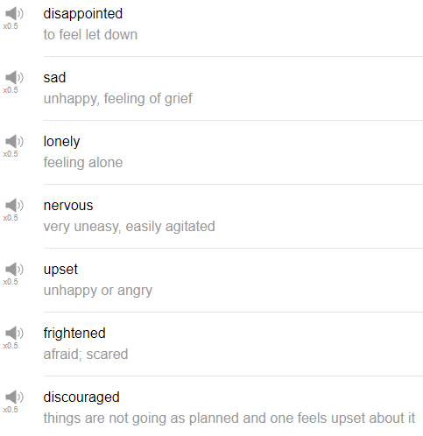

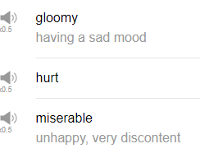

|  |
| --- |
| Oh! Hi, everybody! Welcome back to Top Words. My name is Alisha, and today we're going to be talking about 10 sad words. These are words that you can use to express a sad feeling. So let's go! |
| 1. Sad. |
| The first word is sad, anytime you feel down, you feel disappointed, just to general not good feeling, you can say, I'm sad. If someone asks you, how are you doing? I'm sad. |
| 2. Disappointed. |
| The next word is disappointed, you can use this with food, with people, with pets if you like. My parents like to use disappointed when they wanted to express that I did not live up to their expectations, they would say, Alisha I'm really disappointed in you, and I felt so bad because it meant their expectation was here and my action was here, so it's very effective. But at the same time it's so motivating. |
| 3. Lonely. |
| The next word is lonely, lonely. I don't want to talk about this word, it's sad. Maybe you've been spending a lot of time alone, or there's someone that you really want to see, or you want to see your family members, or maybe you're working too much, I don't know, whatever it is, maybe you just, you feel like you want to talk to people, or you want to see people, be around people, but you can't, you can use the word lonely to describe that feeling. I've only been working for the last few months, I haven't had a chance to spend much time with my friends, I'm feeling kind of lonely. |
| 4. Nervous. |
| The next word is nervous. Nervous is used for any tension, any anxiety, excited but in a bad way about something. When I was a child before my piano performances, I would get so nervous, I would be so nervous my hands would start to shake and then I couldn't play the piece I've been practicing for months. That's why this is great because you're not here. Forgive me! Don't be disappointed in me! |
| 5. Upset. |
| Upset is a really really useful word, anytime you feel sad, angry, depressed, disappointed, unhappy, in general, you can say I'm upset, or he or she is upset. It's just a general unhappy word but it doesn't mean unhappy, it just means something is wrong, there's a way a person usually behaves, but I'm upset means something's not right. In a sentence, I might say, I'm really upset about my performance last year, I was too nervous and my parents were disappointed in me, I'm sad now. |
| 6. Frightened. |
| Frightened just means you're afraid, you're scared of something, like when you go to a movie and it's really scary, you can say I was frightened. Frightened is not a word that I'd use in everyday conversation though. I might read this word in a book, I suppose, but I can't remember the last time I said "I'm very frightened," like, I was frightened, that's a frightening movie. It feels a little bit formal, so you might read this word more often than you actually say this word frightened. |
| 7. Discouraged. |
| The next word is discouraged. If you're trying to do something, like, at your job or as a hobby or whatever, but it's really really difficult, or you're receiving a lot of criticism, or it's just not going as you planned, you can say "I'm feeling discouraged." that sad or that upset feeling of wanting to do something but not being able to, or having a hard time doing that. I'm feeling a little bit discouraged about my recent work project, for example. |
| 8. Gloomy. |
| Gloomy, i guess you could use gloomy to describe someone's mood, just they seem a bit down, they seem a bit sad, they're not maybe saying very much, they don't want to participate in things, that might be someone who's gloomy. We also use gloomy for, like, an atmosphere in a room, or in a place, in a building, something that's a bit dark, maybe it's really, like, cloudy, you can use gloomy to describe the weather as well. Just something dark, cloudy, maybe foggy, kinda, just a sad feeling, really. In a sentence, my friend seems kind of gloomy today, she hasn't said very much and I saw her crying in the bathroom. |
| 9. Hurt. |
| The next word is hurt. If someone criticizes you or if someone says bad things about you, or you feel sad, you feel down, but basically it's someone else is the cause of that, you can say, I feel hurt, or I was hurt by your comments. So it can be used as a verb or as an adjective. So as a verb, I was hurt by your comment. As an adjective, I feel hurt. Another expression that's commonly used is you hurt my feelings, in that case it's used as a verb, you hurt my feelings. So hurt typically, maybe when you think of the word hurt it means to wound or to injure something, in this case your feelings are the thing being injured or being hurt. So, you hurt my feelings is a very very common one. |
| 10. Miserable. |
| The next word is miserable, she says laughing. Miserable means very very sad, so maybe here we have sad, I don't even know what the next one is would be after sad, sad and gloomy, miserable, depressed, I don't know, these are just all very unhappy things going on in this word spectrum I'm building here with my hands. Something bad has happened in your life or in someone else's life and you need a word stronger than sad to describe that, you can use miserable. So, like, I lost my job and I haven't been able to find a new one, I'm miserable. Or my boyfriend or my girlfriend broke up with me, I'm miserable. It's usually for something a bit serious in your life, miserable. |
| And that's the end! Those are 10 sad words, somehow that didn't get too depressing, I hope. Anyway, give them a try the next time you need to more accurately describe your feelings, or to describe someone else's feelings, they're pretty useful actually, I think. Thanks very much for joining us for this lesson! If you haven't already, please be sure to subscribe to our channel for more fun stuff, and we'll see you again soon. Bye! |